https://jira.tcsbank.ru/browse/INCR-449
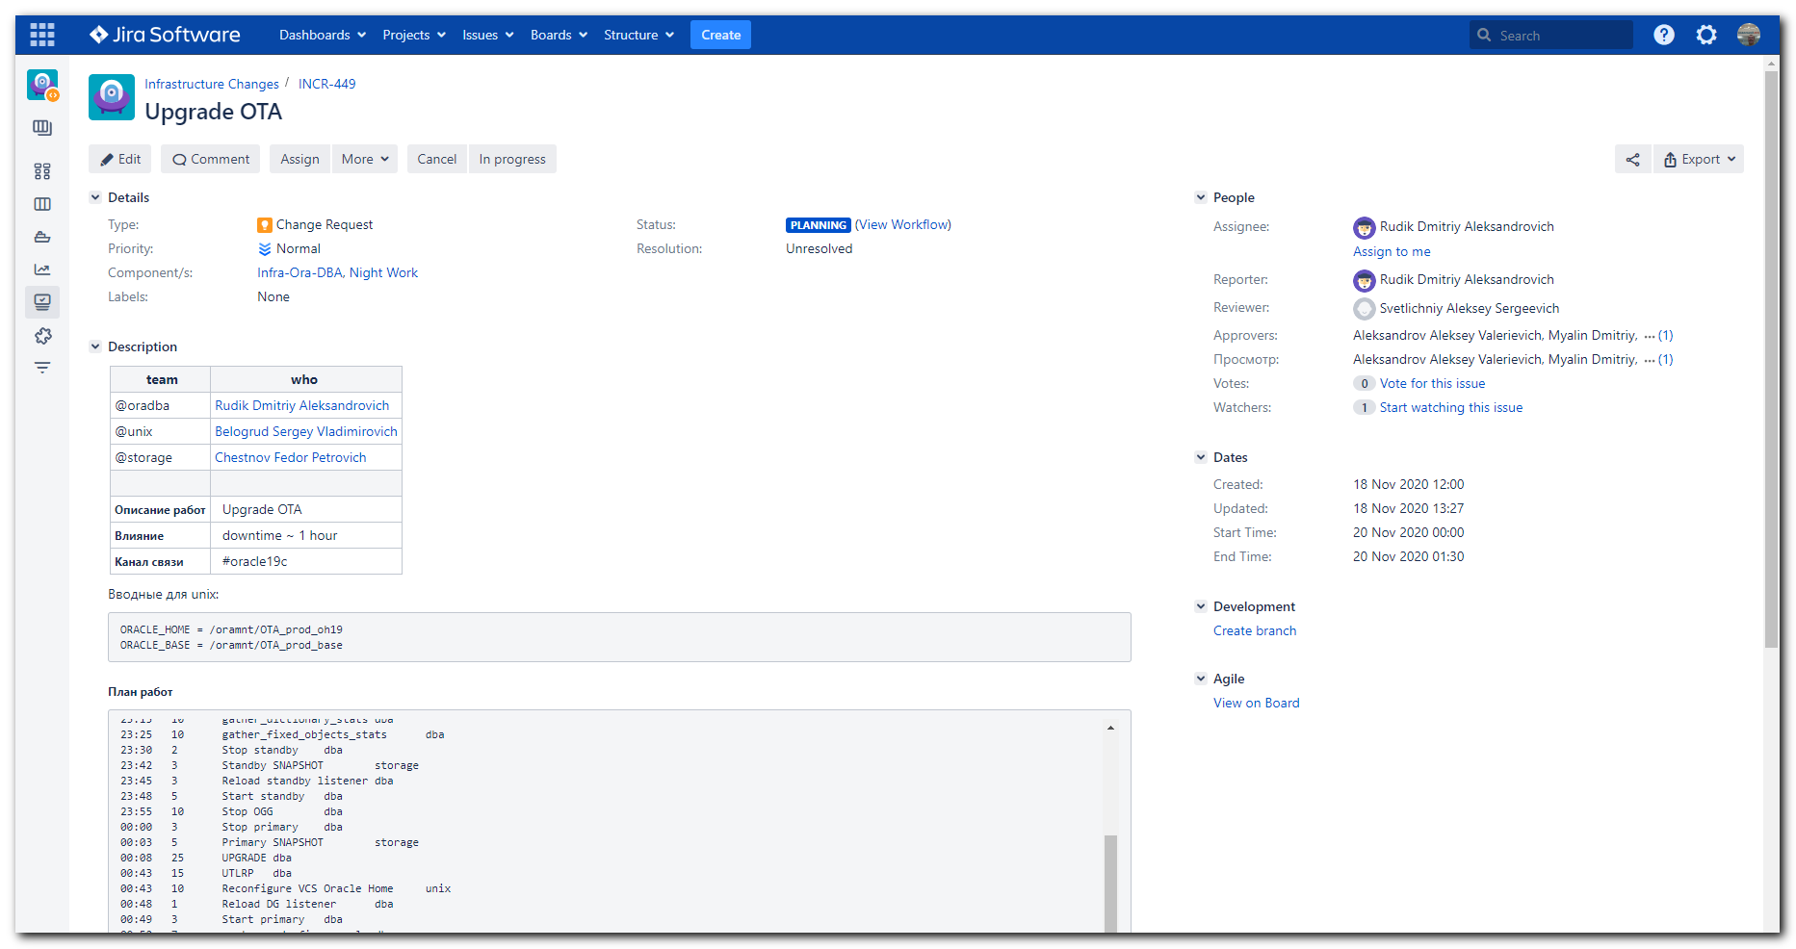

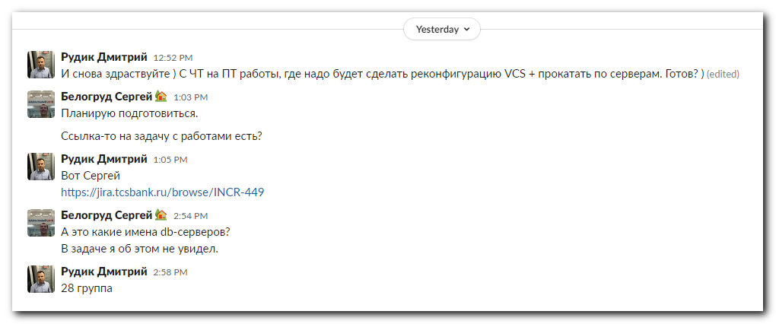

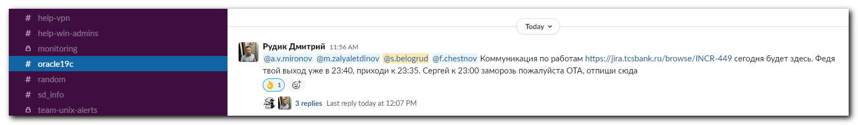

Вводные для unix:

ORACLE_HOME = /oramnt/OTA_prod_oh19
ORACLE_BASE = /oramnt/OTA_prod_base

Time Duration (min) Aсtion Group
20:00 30 Remove standby backlog 240 -> 0 dba
20:00 5 ASYNC + MAX PERFORMANCE dba
20:00 5 Change SUNDAY_WINDOW dba
22:40 5 Disable backup/speed limit storage
22:40 5 Disable CRONHOUR dba
22:40 5 Freeze VCS unix
22:50 5 Purge DBA_RECYCLEBIN dba
22:55 10 dbms_scheduler.purge_log dba
23:00 10 preupgrade_fixups.sql dba
23:15 10 gather_dictionary_stats dba
23:25 10 gather_fixed_objects_stats dba
23:30 2 Stop standby dba
23:42 3 Standby SNAPSHOT storage
23:45 3 Reload standby listener dba
23:48 5 Start standby dba
23:55 10 Stop OGG dba
00:00 3 Stop primary dba
00:03 5 Primary SNAPSHOT storage
00:08 25 UPGRADE dba
00:43 15 UTLRP dba
00:43 10 Reconfigure VCS Oracle Home unix
00:48 1 Reload DG listener dba
00:49 3 Start primary dba
00:52 7 postupgrade_fixups.sql dba
00:52 5 Check INVALIDS app
00:55 2 Unfreeze VCS unix
00:55 2 Relocate prod1 -> prod2 -> prod1 VCS unix
00:55 10 gather_dictionary_stats dba
00:55 10 gather_fixed_objects_stats dba
01:00 10 Start OGG dba
01:00 5 Enable CRONHOUR dba
01:10 5 Enable backup/speed limit storage

# I’m doing this work as I noted same works in “20200903 Planned works on db server - change oracle home dir to 19”.
#

[13:17:04 root@m1-db28-dr ~]# hastatus -sum | grep -e "OTA"
B OraOTA ds-db28-prod1 Y N ONLINE
B OraOTA ds-db28-prod2 Y N OFFLINE
B OraOTA m1-db28-dr Y N OFFLINE
[13:17:46 root@m1-db28-dr ~]#

[13:20:35 root@ds-db28-prod1 ~]# mount | grep -e "OTA" | awk '{print $1"\t"$3}'
a700-ota-prod-nfs:/OTA_prod_home /opt/oracle/product/OTA
a700-ota-prod-nfs:/OTA_prod_redo /oramnt/OTA_prod_redo
a700-ota-prod-nfs:/OTA_prod_di01 /oramnt/OTA_prod_di01
a700-ota-prod-nfs:/OTA_prod_arch /oramnt/OTA_prod_arch
aff8080-arch-prod-nfs:/OTA_prod_arch /oramnt/OTA_prod_arc
a700-ota-prod-nfs:/OTA_prod_home/oh19 /oramnt/OTA_prod_oh19
a700-ota-prod-nfs:/OTA_prod_home/base /oramnt/OTA_prod_base
[13:21:02 root@ds-db28-prod1 ~]#

#
# https://wiki.tcsbank.ru/pages/viewpage.action?pageId=415273314
# При поиске замене обращаем внимание ра вхождения имени базы в имена в нижнем регистре.
# В шаблоне. Сначала поиск-замена “OPS” на “OTA”. Потом поиск-замена “a700-OTA” на “a700-ota”. Потом поиск замена “oh18” на “oh19”.
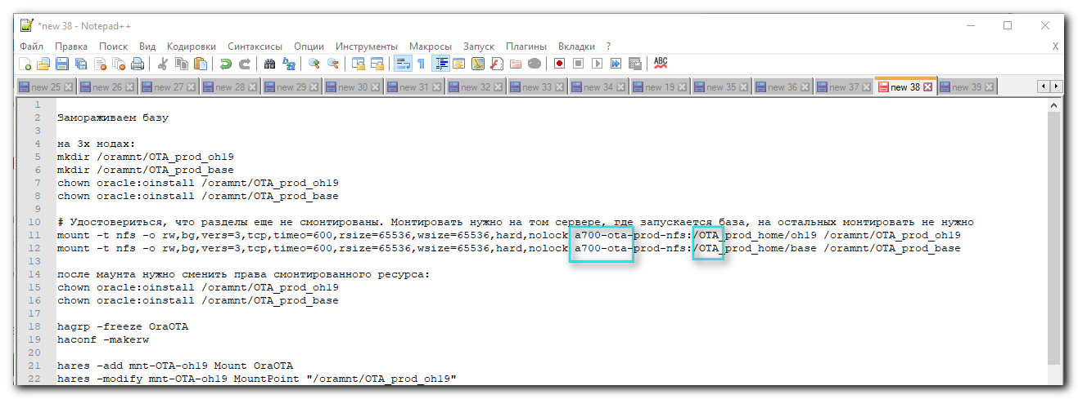

Замораживаем базу

на 3х нодах:
mkdir /oramnt/OTA_prod_oh19
mkdir /oramnt/OTA_prod_base
chown oracle:oinstall /oramnt/OTA_prod_oh19
chown oracle:oinstall /oramnt/OTA_prod_base

# Удостовериться, что разделы еще не смонтированы. Монтировать нужно на том сервере, где запускается база, на остальных монтировать не нужно
mount -t nfs -o rw,bg,vers=3,tcp,timeo=600,rsize=65536,wsize=65536,hard,nolock a700-ota-prod-nfs:/OTA_prod_home/oh19 /oramnt/OTA_prod_oh19
mount -t nfs -o rw,bg,vers=3,tcp,timeo=600,rsize=65536,wsize=65536,hard,nolock a700-ota-prod-nfs:/OTA_prod_home/base /oramnt/OTA_prod_base

после маунта нужно сменить права смонтированного ресурса:
chown oracle:oinstall /oramnt/OTA_prod_oh19
chown oracle:oinstall /oramnt/OTA_prod_base

hagrp -freeze OraOTA
haconf -makerw

hares -add mnt-OTA-oh19 Mount OraOTA
hares -modify mnt-OTA-oh19 MountPoint "/oramnt/OTA_prod_oh19"
hares -modify mnt-OTA-oh19 BlockDevice "a700-ota-prod-nfs:/OTA_prod_home/oh19"
hares -modify mnt-OTA-oh19 FSType nfs
hares -modify mnt-OTA-oh19 MountOpt "rw,bg,vers=3,tcp,timeo=600,rsize=65536,wsize=65536,hard,nolock"
hares -modify mnt-OTA-oh19 Critical 0
hares -modify mnt-OTA-oh19 Enabled 0

hares -add mnt-OTA-base Mount OraOTA
hares -modify mnt-OTA-base MountPoint "/oramnt/OTA_prod_base"
hares -modify mnt-OTA-base BlockDevice "a700-ota-prod-nfs:/OTA_prod_home/base"
hares -modify mnt-OTA-base FSType nfs
hares -modify mnt-OTA-base MountOpt "rw,bg,vers=3,tcp,timeo=600,rsize=65536,wsize=65536,hard,nolock"
hares -modify mnt-OTA-base Critical 0
hares -modify mnt-OTA-base Enabled 0

hares -link lsnr-OTA mnt-OTA-oh19
hares -link lsnr-OTA-dgr mnt-OTA-oh19
hares -link mnt-OTA-oh19 proxy-OTA-kNFS
hares -link ora-OTA mnt-OTA-oh19
hares -link GxClusterPlugin_OraOTA mnt-OTA-oh19

hares -link lsnr-OTA mnt-OTA-base
hares -link lsnr-OTA-dgr mnt-OTA-base
hares -link mnt-OTA-base proxy-OTA-kNFS
hares -link ora-OTA mnt-OTA-base
hares -link GxClusterPlugin_OraOTA mnt-OTA-base

hares -unlink lsnr-OTA mnt-OTA-orahome
hares -unlink lsnr-OTA-dgr mnt-OTA-orahome
hares -unlink mnt-OTA-orahome proxy-OTA-kNFS
hares -unlink ora-OTA mnt-OTA-orahome
hares -unlink GxClusterPlugin_OraOTA mnt-OTA-orahome

Меняем Home в листенерах (2шт) и oracle (1шт)
Меняем PFILE в Oracle /oramnt/OTA_prod_base/dbs/initOTA.ora и проверить наличие директории - файла может и не быть !

lsnr-OTA и lsnr-OTA-dgr
Home /oramnt/OTA_prod_oh19
TnsAdmin /oramnt/OTA_prod_oh19/network/admin/
ora-OTA
Home /oramnt/OTA_prod_oh19
Pfile /oramnt/OTA_prod_oh19/dbs/initOTA.ora

hares -modify lsnr-OTA Home /oramnt/OTA_prod_oh19
hares -modify lsnr-OTA TnsAdmin /oramnt/OTA_prod_oh19/network/admin/
hares -modify lsnr-OTA-dgr Home /oramnt/OTA_prod_oh19
hares -modify lsnr-OTA-dgr TnsAdmin /oramnt/OTA_prod_oh19/network/admin/
hares -modify ora-OTA Home /oramnt/OTA_prod_oh19
hares -modify ora-OTA Pfile /oramnt/OTA_prod_oh19/dbs/initPG.ora

делаем Enabled + Critical на листенеры и oracle

hares -modify mnt-OTA-oh19 Enabled 1
hares -modify mnt-OTA-base Enabled 1

hares -modify mnt-OTA-oh19 Critical 1
hares -modify mnt-OTA-base Critical 1

УДАЛЯЕМ СТАРЫЙ HOME

hares -delete mnt-OTA-orahome

hacf -verify /etc/VRTSvcs/conf/config/ && haconf -dump -makero

если необходимо

1) mount -t nfs -o ro,bg,vers=3,tcp,timeo=600,rsize=65536,wsize=65536,hard,nolock a700-ota-prod-nfs:/OTA_prod_home /oramnt/OTA_prod_base

Размораживаем базу

[23:07:20 root@m1-db28-dr ~]# tail -f /var/VRTSvcs/log/engine_A.log
2020/11/19 12:10:16 VCS WARNING V-16-1-50086 Mem usage on m1-db28-dr is 82%
2020/11/19 13:23:51 VCS INFO V-16-1-53504 VCS Engine Alive message!!
2020/11/19 14:10:16 VCS WARNING V-16-1-50086 Mem usage on m1-db28-dr is 82%
2020/11/19 16:10:16 VCS WARNING V-16-1-50086 Mem usage on m1-db28-dr is 82%
2020/11/19 17:23:52 VCS INFO V-16-1-53504 VCS Engine Alive message!!
2020/11/19 18:10:16 VCS WARNING V-16-1-50086 Mem usage on m1-db28-dr is 82%
2020/11/19 20:10:16 VCS WARNING V-16-1-50086 Mem usage on m1-db28-dr is 82%
2020/11/19 21:23:53 VCS INFO V-16-1-53504 VCS Engine Alive message!!
2020/11/19 22:10:16 VCS WARNING V-16-1-50086 Mem usage on m1-db28-dr is 82%
2020/11/19 23:00:03 VCS INFO V-16-1-50159 User fired command: hagrp -freeze OraOTA from node ds-db28-prod2

[23:07:40 root@m1-db28-dr ~]#

[s.belogrud@TCS4357]# ssh bsv@m1-db28-dr
Last login: Thu Nov 19 23:07:15 2020 from tcs4357.tcsbank.ru
[bsv@m1-db28-dr ~]$ sudo -i
[sudo] password for bsv:
[00:33:15 root@m1-db28-dr ~]# mkdir /oramnt/OTA_prod_oh19
mkdir: cannot create directory ‘/oramnt/OTA_prod_oh19’: File exists
[00:34:17 root@m1-db28-dr ~]# mkdir /oramnt/OTA_prod_base
mkdir: cannot create directory ‘/oramnt/OTA_prod_base’: File exists
[00:34:17 root@m1-db28-dr ~]# chown oracle:oinstall /oramnt/OTA_prod_oh19
[00:34:17 root@m1-db28-dr ~]# chown oracle:oinstall /oramnt/OTA_prod_base
[00:34:17 root@m1-db28-dr ~]#

[s.belogrud@TCS4357]# ssh bsv@ds-db28-prod2
Last login: Thu Nov 19 16:40:48 2020 from tcs4357.tcsbank.ru
[bsv@ds-db28-prod2 ~]$ sudo -i
[sudo] password for bsv:
[00:33:32 root@ds-db28-prod2 ~]# mkdir /oramnt/OTA_prod_oh19
mkdir: cannot create directory ‘/oramnt/OTA_prod_oh19’: File exists
[00:34:29 root@ds-db28-prod2 ~]# mkdir /oramnt/OTA_prod_base
mkdir: cannot create directory ‘/oramnt/OTA_prod_base’: File exists
[00:34:29 root@ds-db28-prod2 ~]# chown oracle:oinstall /oramnt/OTA_prod_oh19
[00:34:29 root@ds-db28-prod2 ~]# chown oracle:oinstall /oramnt/OTA_prod_base
[00:34:29 root@ds-db28-prod2 ~]#

[s.belogrud@TCS4357]# ssh bsv@ds-db28-prod1
Warning: Permanently added 'ds-db28-prod1' (RSA) to the list of known hosts.
Last login: Thu Nov 19 13:20:31 2020 from tcs4357.tcsbank.ru
[bsv@ds-db28-prod1 ~]$ sudo -i
[sudo] password for bsv:
[00:33:49 root@ds-db28-prod1 ~]# mkdir /oramnt/OTA_prod_oh19
mkdir: cannot create directory ‘/oramnt/OTA_prod_oh19’: File exists
[00:34:36 root@ds-db28-prod1 ~]# mkdir /oramnt/OTA_prod_base
mkdir: cannot create directory ‘/oramnt/OTA_prod_base’: File exists
[00:34:36 root@ds-db28-prod1 ~]# chown oracle:oinstall /oramnt/OTA_prod_oh19
[00:34:36 root@ds-db28-prod1 ~]# chown oracle:oinstall /oramnt/OTA_prod_base
[00:34:36 root@ds-db28-prod1 ~]# mount -t nfs -o rw,bg,vers=3,tcp,timeo=600,rsize=65536,wsize=65536,hard,nolock a700-ota-prod-nfs:/OTA_prod_home/oh19 /oramnt/OTA_prod_oh19
mount.nfs: /oramnt/OTA_prod_oh19 is busy or already mounted
[00:35:15 root@ds-db28-prod1 ~]# mount -t nfs -o rw,bg,vers=3,tcp,timeo=600,rsize=65536,wsize=65536,hard,nolock a700-ota-prod-nfs:/OTA_prod_home/base /oramnt/OTA_prod_base
mount.nfs: /oramnt/OTA_prod_base is busy or already mounted
[00:35:15 root@ds-db28-prod1 ~]# chown oracle:oinstall /oramnt/OTA_prod_oh19
[00:35:38 root@ds-db28-prod1 ~]# chown oracle:oinstall /oramnt/OTA_prod_base
[00:35:38 root@ds-db28-prod1 ~]# hagrp -freeze OraOTA
VCS WARNING V-16-1-40208 Group is already temporarily frozen
[00:35:54 root@ds-db28-prod1 ~]# haconf -makerw
[00:35:54 root@ds-db28-prod1 ~]#
[00:36:08 root@ds-db28-prod1 ~]# hares -add mnt-OTA-oh19 Mount OraOTA
hares -modify mnt-OTA-oh19 BlockDevice "a700-ota-prod-nfs:/OTA_prod_home/oh19"
hares -modify mnt-OTA-oh19 FSType nfs
hares -modify mnt-OTA-oh19 MountOpt "rw,bg,vers=3,tcp,timeo=600,rsize=65536,wsize=65536,hard,nolock"
hares -modify mnt-OTA-oh19 Critical 0
hares -modify mnt-OTA-oh19 Enabled 0
VCS NOTICE V-16-1-10242 Resource added. Enabled attribute must be set before agent monitors
[00:36:12 root@ds-db28-prod1 ~]# hares -modify mnt-OTA-oh19 MountPoint "/oramnt/OTA_prod_oh19"
[00:36:12 root@ds-db28-prod1 ~]# hares -modify mnt-OTA-oh19 BlockDevice "a700-ota-prod-nfs:/OTA_prod_home/oh19"
[00:36:12 root@ds-db28-prod1 ~]# hares -modify mnt-OTA-oh19 FSType nfs
[00:36:12 root@ds-db28-prod1 ~]# hares -modify mnt-OTA-oh19 MountOpt "rw,bg,vers=3,tcp,timeo=600,rsize=65536,wsize=65536,hard,nolock"
[00:36:12 root@ds-db28-prod1 ~]# hares -modify mnt-OTA-oh19 Critical 0
[00:36:12 root@ds-db28-prod1 ~]# hares -modify mnt-OTA-oh19 Enabled 0
[00:36:12 root@ds-db28-prod1 ~]#
[00:36:14 root@ds-db28-prod1 ~]# hares -add mnt-OTA-base Mount OraOTA
VCS NOTICE V-16-1-10242 Resource added. Enabled attribute must be set before agent monitors
[00:36:28 root@ds-db28-prod1 ~]# hares -modify mnt-OTA-base MountPoint "/oramnt/OTA_prod_base"
[00:36:28 root@ds-db28-prod1 ~]# hares -modify mnt-OTA-base BlockDevice "a700-ota-prod-nfs:/OTA_prod_home/base"
[00:36:28 root@ds-db28-prod1 ~]# hares -modify mnt-OTA-base FSType nfs
[00:36:28 root@ds-db28-prod1 ~]# hares -modify mnt-OTA-base MountOpt "rw,bg,vers=3,tcp,timeo=600,rsize=65536,wsize=65536,hard,nolock"
[00:36:28 root@ds-db28-prod1 ~]# hares -modify mnt-OTA-base Critical 0
[00:36:28 root@ds-db28-prod1 ~]# hares -modify mnt-OTA-base Enabled 0
[00:36:28 root@ds-db28-prod1 ~]#
[00:36:29 root@ds-db28-prod1 ~]# hares -link lsnr-OTA mnt-OTA-oh19
[00:36:43 root@ds-db28-prod1 ~]# hares -link lsnr-OTA-dgr mnt-OTA-oh19
[00:36:43 root@ds-db28-prod1 ~]# hares -link mnt-OTA-oh19 proxy-OTA-kNFS
[00:36:43 root@ds-db28-prod1 ~]# hares -link ora-OTA mnt-OTA-oh19
[00:36:43 root@ds-db28-prod1 ~]# hares -link GxClusterPlugin_OraOTA mnt-OTA-oh19
[00:36:43 root@ds-db28-prod1 ~]#
[00:36:44 root@ds-db28-prod1 ~]# hares -link lsnr-OTA mnt-OTA-base
[00:36:56 root@ds-db28-prod1 ~]# hares -link lsnr-OTA-dgr mnt-OTA-base
[00:36:56 root@ds-db28-prod1 ~]# hares -link mnt-OTA-base proxy-OTA-kNFS
[00:36:56 root@ds-db28-prod1 ~]# hares -link ora-OTA mnt-OTA-base
[00:36:57 root@ds-db28-prod1 ~]# hares -link GxClusterPlugin_OraOTA mnt-OTA-base
[00:36:57 root@ds-db28-prod1 ~]#
[00:36:58 root@ds-db28-prod1 ~]# hares -unlink lsnr-OTA mnt-OTA-orahome
[00:37:09 root@ds-db28-prod1 ~]# hares -unlink lsnr-OTA-dgr mnt-OTA-orahome
[00:37:09 root@ds-db28-prod1 ~]# hares -unlink mnt-OTA-orahome proxy-OTA-kNFS
[00:37:09 root@ds-db28-prod1 ~]# hares -unlink ora-OTA mnt-OTA-orahome
[00:37:09 root@ds-db28-prod1 ~]# hares -unlink GxClusterPlugin_OraOTA mnt-OTA-orahome
[00:37:09 root@ds-db28-prod1 ~]#
[00:37:10 root@ds-db28-prod1 ~]# hares -modify lsnr-OTA Home /oramnt/OTA_prod_oh19
[00:37:34 root@ds-db28-prod1 ~]# hares -modify lsnr-OTA TnsAdmin /oramnt/OTA_prod_oh19/network/admin/
[00:37:34 root@ds-db28-prod1 ~]# hares -modify lsnr-OTA-dgr Home /oramnt/OTA_prod_oh19
[00:37:34 root@ds-db28-prod1 ~]# hares -modify lsnr-OTA-dgr TnsAdmin /oramnt/OTA_prod_oh19/network/admin/
[00:37:34 root@ds-db28-prod1 ~]# hares -modify ora-OTA Home /oramnt/OTA_prod_oh19
[00:37:34 root@ds-db28-prod1 ~]# hares -modify ora-OTA Pfile /oramnt/OTA_prod_oh19/dbs/initPG.ora
[00:37:34 root@ds-db28-prod1 ~]#
[00:37:36 root@ds-db28-prod1 ~]# hares -modify mnt-OTA-oh19 Enabled 1
[00:37:53 root@ds-db28-prod1 ~]# hares -modify mnt-OTA-base Enabled 1
[00:37:53 root@ds-db28-prod1 ~]#
[00:37:55 root@ds-db28-prod1 ~]# hares -modify mnt-OTA-oh19 Critical 1
[00:38:04 root@ds-db28-prod1 ~]# hares -modify mnt-OTA-base Critical 1
[00:38:04 root@ds-db28-prod1 ~]#
[00:38:05 root@ds-db28-prod1 ~]# hares -delete mnt-OTA-orahome
[00:38:24 root@ds-db28-prod1 ~]#
[00:38:25 root@ds-db28-prod1 ~]# hacf -verify /etc/VRTSvcs/conf/config/ && haconf -dump -makero
[00:38:35 root@ds-db28-prod1 ~]#

